
We are delighted that you are interested in becoming a part of our family at Lowcountry Learners. Our focus is to nurture children and give parents peace of mind, knowing each child is in a loving environment. We will provide an encouraging educational experience by helping promote social interaction, and develop their emotional, physical, and cognitive skills.
Our Mission Statement
Lowcountry Learners is an early childcare learning center and education provider. Our goals are to encourage learning in a creative environment through exploration while building lasting friendships and helping each child feel empowered with self-confidence and independence.
GENERAL INFORMATON
Owners
Karen Ullrich & Sean McDuffie
Director Assistant Director
Karen Ullrich Caroline Mazyck
Hours of Operation
Monday - Friday 7AM - 6PM
WE WILL BE CLOSED ON:
New Year's Eve
New Year’s Day Presidents Day
Good Friday
Memorial Day
Independence Day
Labor Day
Thanksgiving Day and the Friday after
Christmas Eve Day
Christmas Day

Enrollment
Lowcountry Learners is a preschool with an emphasis on STEM (science, technology, engineering, and math). We accept children from 2-5 years of age. Enrollment is available to any child regardless of race, color, religion, sex, or national origin. Lowcountry Learners does not discriminate in enrollment and complies with the Americans with Disabilities Act. English is our primary language and at this time we cannot accommodate children who do not speak English. Our school calendar will be from the designated start date in August and continue through the designated last day for the school year in May. Immediately following the school year, we will start our Summer Camp programs.
Our Staff
Lowcountry Learners believe that as teachers we have a strong influence on children’s lives. We look for staff that pride themselves on offering warm, loving, and nurturing experiences to every child that walks through our doors. Exceptional educators and role models make our facility stand out in the education field.
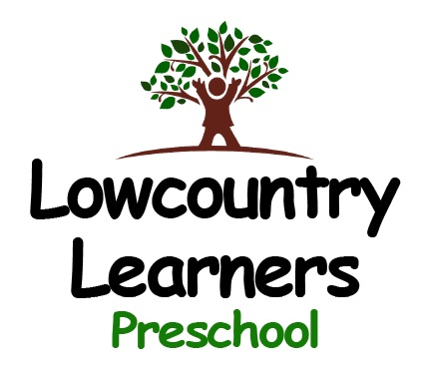
  - Registration
$125 per child for new families
$125 per child for returning families
Registration for the upcoming school year is due February 1st of each calendar year. The registration fee is non-refundable.
Tuition
- Age | - Rate
- 2’s | - $315/week
- 3’s | - $305/week
- 4’s & 5’s | - $305/week
Tuition can be paid bi-weekly or monthly and is non-transferable. Tuition is due on the Friday prior to the upcoming week. We do NOT accept cash, checks or credit cards. Lowcountry Learners uses Tuition Express to automatically withdraw tuition from your bank account after a pre-authorized agreement is completed and signed. There are no deductions for sickness, absence, or holidays.
What is Tuition Express?
Tuition Express is the premier payment processing service in the childcare industry. With Tuition Express parents have the ability to receive their payment receipts via email. TuituonExpress.com keeps parents in touch with their childcare facility and their personal finances.

Lowcountry Learners
1210 Hospital Drive
Mount Pleasant, SC 29464

1210 Hospital Drive
Mount Pleasant, SC 29464
(843) 388-1949
lowcountrylearners.com
email: info@lowcountrylearners.com
Philosophy
Our belief is that children experience the best growth when they feel secure and are in a loving atmosphere. Therefore, Lowcountry Learners provides a warm, caring, gentle, loving, clean, comfortable and safe environment for each child. Our center uses constructive guidance and positive reinforcement. We help encourage respect for each other and the willingness to express feelings. Our Staff establishes routines that are consistent in order to help each child flourish. We are committed to the children learning and believing that educators are important role models, as well as our educators knowing and understanding they are important role models to the children. Working together, we believe that this will help ensure that developmental goals and confidence are gained while at Lowcountry Learners. The mutual respect and collaboration between parents, teachers, staff, children and peers are of vital importance in helping our students meet their goals of independence and self-awareness.
Curriculum and STEM
Our curriculum encourages exploration of the world around us with an emphasis on STEM (science, technology, engineering and math). With this learning style teachers will be using hands on methods, while meeting the needs of each individual child. To ensure that every student is getting the appropriate level of learning, our teachers will evaluate each child after enrollment. As each student progresses phonics and reading will also be introduced.

